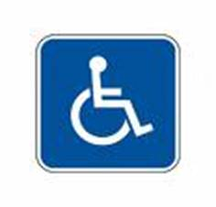
Notice of Disruption
Type of disruption _________________________________
Reason for disruption ______________________________
Duration of disruption ______________________________
Alternative facilities or services_______________________

We apologize for any inconvenience that this disruption may cause. If you have any questions or concerns, please call (807)344-4994, to speak to our receptionist, who will be happy to assist you.

